[](https://www.unitbv.ro/) [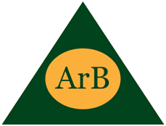](http://www.arb.uk.com/) 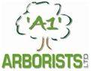 [](https://aba-skills.com/)

[](http://mendelu.cz/) [](https://sgls.si/sola-postojna/) [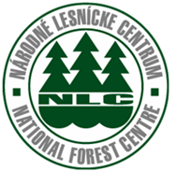](https://web.nlcsk.org/)

[](http://www.ovt.lv/) [](https://www.coillte.ie/)

[](https://ec.europa.eu/programmes/erasmus-plus/projects/eplus-project-details/#project/2019-1-UK01-KA202-061846)