[](https://www.unitbv.ro/)[](https://ec.europa.eu/programmes/erasmus-plus/projects/eplus-project-details/#project/2019-1-CZ01-KA202-061371) [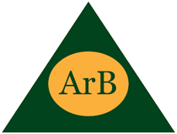](http://www.arb.uk.com/) 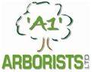 [](https://www.bvm-baumpflege.de/) [](http://www.ccagency.cz)[](https://aba-skills.com/) [](https://www.facebook.com/pg/info.irm/about/)

[](https://www.facebook.com/isaakk.biedriba) [](http://mendelu.cz/) [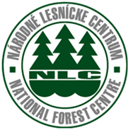](https://web.nlcsk.org/) [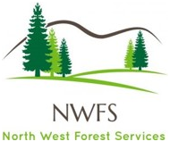](https://nwfs.ie/)

[](https://sgls.si/sola-postojna/)